PORTFOLIO LEAD
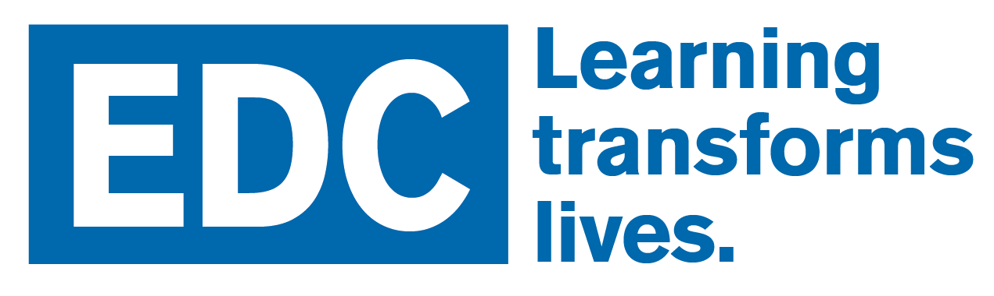
Job Opportunities
Grade 14 – MANAGEMENT – REFERENCE #: PL061918
Regular – Full-Time Position; Waltham, MA

EDUCATION DEVELOPMENT CENTER (EDC)
EDC is one of the world’s leading nonprofit research and development firms. EDC designs, implements, and evaluates programs to improve education, health, and economic opportunity worldwide. Collaborating with both public and private partners, we strive for a world where all people are empowered to live healthy, productive lives.

EDC has a commitment to promoting equity and access to high quality education and health services that contribute to thriving communities where people from diverse backgrounds learn, live, and work together. EDC expresses its commitment to increasing equity through its strategies, services and products, which contribute to building capacity and transforming lives.

EDC is committed to diversity and inclusion in the workplace.

The Early Childhood Portfolio has an opening for a Portfolio Lead, reporting to the Senior Vice President of the U.S. Division.

The Early Childhood Portfolio at EDC builds the capacity of individuals, practitioners/intermediaries, and systems to improve outcomes for children prenatal to age 8. Our work is based on the belief that early childhood is the foundation for all that follows across a person’s life span. By attending to programs, systems, and policies designed to meet children’s needs, and supporting the full range of caregivers who nourish and nurture young children—parents, teachers, home visitors, community leaders, and health care providers—we secure strong, productive, equitable futures for all. We focus in particular on building the capacity of educators, agencies and communities to sustain improvements, supporting children who are dual language learners, meeting the needs of children from disadvantaged communities, engaging and supporting families. and addressing issues related to children’s health and mental health.

This portfolio includes more than 60 early childhood content experts, researchers, training and technical assistance (TTA) providers, and materials developers who lead and work on dozens of projects, with an annual revenue of about $12.5M. Current lines of work include: federally funded TTA centers that support state leaders; federal and state initiatives that support education and health practitioners; R&D efforts that result in high-visibility products, such as curricula, hands-on materials and policy briefs; and influential research and evaluation studies on behalf of partners and clients. The content focus within the portfolio is diverse, including home visiting, infant and early childhood mental health, early literacy, STEM learning, two-generation supports, child care, Head Start, and prenatal through grade three systems.

ESSENTIAL FUNCTIONS
EDC is seeking a leader with deep experience in early childhood programs and policy. This leader will oversee the current portfolio and staff, ensuring high quality execution of projects and deliverables. The leader also will develop and execute a business development strategy that builds on and expands EDC’s early childhood work. A successful Early Childhood Portfolio Lead will understand the early childhood landscape, from federal and state initiatives to collaborations led by the philanthropic sector, and will be able to identify trends, opportunities, and connections that can inform EDC’s early childhood strategy. The Portfolio Lead also will have a network of relationships in the field and a proven track record of strong leadership and effective management. The person in this position is expected to communicate clearly and courteously; to develop and maintain positive relationships with clients, consultants, collaborators, co-workers, field sites, and funders; and to work respectfully with EDC colleagues. The job requires adherence to EDC policies & procedures.

The Portfolio Lead
• Develops, communicates and implements strategic and technical vision for the Early Childhood Portfolio
• Is responsible for programmatic/technical and administrative/business/financial success of the Portfolio
• Is accountable for leading business development initiatives — including prospecting, proposal development, and strategic market positioning — to ensure long-term financial viability for the Portfolio and EDC
• Evaluates business opportunities for risk to Portfolio & EDC and makes appropriate plans and decisions in conjunction with Portfolio staff and/or US Division Leadership
• Is accountable and responsible for Portfolio financial & administrative management in accordance with EDC requirements
• Is part of the US Division Leadership Team that sets and oversees policies, procedures, systems, resources, and communications to maximize efficiency, reduce costs, increase quality, and promote innovation & excellence
• Oversees compliance and quality across projects and programs
• Works with programmatic and communications staff to maintains and increase EDC’s reputation and visibility in Early Childhood
• Actively presents progress &/or results in public fora &/or publications and supports the same among Portfolio staff
• Provides strategic insight and recommendations to EDC Leadership &/or the Board of Directors (if requested)
• Has overall responsibility for the management of the portfolio, including direct supervision of the senior staff.
- Is responsible for communicating and modeling EDC and division policies and goals to portfolio staff and for raising concerns of portfolio staff to division leadership.

The Portfolio Lead also
• Promotes strong ethics, ensuring fair & equitable treatment of staff & partners and contributing to EDC’s commitment to diversity
• Fosters overall atmosphere of productivity, creativity and innovation
• Promotes active collaboration and partnership across portfolios and divisions
• Builds internal and external relationships for future collaborations, including to seek new business opportunities
• Serves on US Division and/or EDC committees
• May lead meetings, negotiations, presentations, and external events
• Troubleshoots problems and facilitates solutions
• Promotes excellent business, client, funder and public relations
• Represents the portfolio and organization with key or potential clients/accounts
• Travels to other EDC offices and to visit funders on a regular basis

QUALIFICATIONS
This position requires demonstrated management experience; educational achievement; excellent writing skills; demonstrable initiative, creativity, and flexibility; ability to work independently, as well as to work effectively in groups; and strong interpersonal & organizational skills. Specific requirements:

• Master’s degree or equivalent combination of training & experience required in a related discipline
• MBA or PhD desirable
• 12–15 years related business, R&D, education or management experience, with minimum of 7–10 years prior business development, project management, &/or grants & contracts management experience, including budget responsibility and staff supervision and development
• Excellent analytical capacity
• Demonstrable skills in leadership, advanced client relations, business development, contract management, and staff development
• Regionally or nationally respected in field of expertise

CONTACT
EDC, 43 Foundry Ave, Waltham, MA 02453

Posted: June 19, 2018

As an EOE/AA employer, EDC does not discriminate in its employment practices due to an applicant’s race, color, religion, sex, sexual orientation, gender identity, national origin, and veteran or disability status. EDC is a smoke-free workplace.

